Title: Eric the Orange Boy Game Storyboard
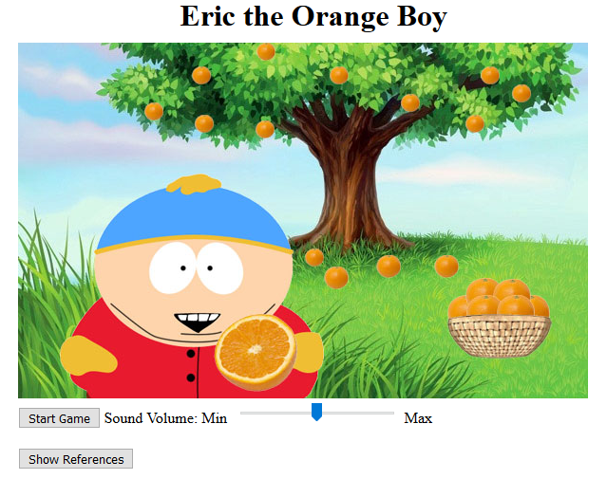

Description | Welcome Page (Appears on clicking the “Play Game” button on the navigation page) | Elements | - Title  - Background image  - “Start Game” button  - Sound volume adjuster  - “Show Reference” button
Duration | Until user starts game | Elements animation | No animation
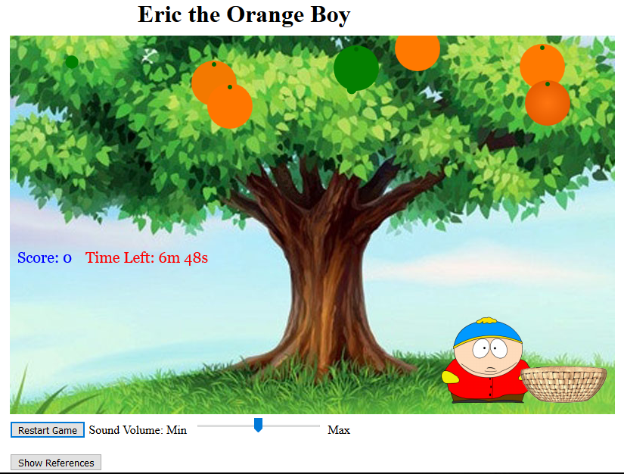

Description | Game scenario | Elements | - Background image  - Eric the collector image  - Basket image  - Orange images  - Score tally  - Countdown  - Intro Music
Duration | 7 min | Elements animation | - Intro Music is played.  - User can move Eric in four directions.  - Basket switches to the other side when Eric passes the middle of the image.  - Countdown starts.  - Oranges start growing and falling.


Description | Orange appearing and growing | Elements |  | Growing oranges
Duration | 5 seconds | Elements animation |  | Orange size increases


Description | Orange ripening | Elements | Ripening oranges
Duration | 4 seconds | Elements animation | Gradually turn from green to orange


Description | Oranges staying on the tree | Elements | Ripe oranges
Duration | 3 seconds | Elements animation | Oranges staying


Description | Oranges falling off the tree | Elements | Falling oranges
Duration | 6 seconds | Elements animation | Oranges falling off the tree
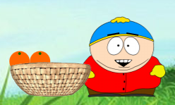

Description | Eric catches oranges | Elements | - Eric’s happy eyebrows  - Eric’s grinning mouth  - Oranges in basket  - Happy sound “Yay”  - Score tally
Duration | 2 seconds | Elements animation | - Eric’s happy eyebrows and grinning mouth appear.  - Falling orange disappears. If the number of oranges in the basket is less than four, an orange will appear in the basket.  - Happy sound is played.  - Score increases by one.
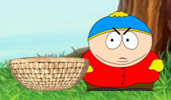

Description | Orange hits Eric | Elements | - Eric’s angry eyebrows  - Eric’s angry eyes  - Painful sounds “Ouch” or “Uhoh”
Duration | 2 seconds | Elements animation | - Eric’s angry eyebrows appear.  - Eric’s angry eyes move.  - Falling orange disappears.  - A painful sound is played. “Ouch” and “Uhoh” are played alternatively.  - Score decreases by one.
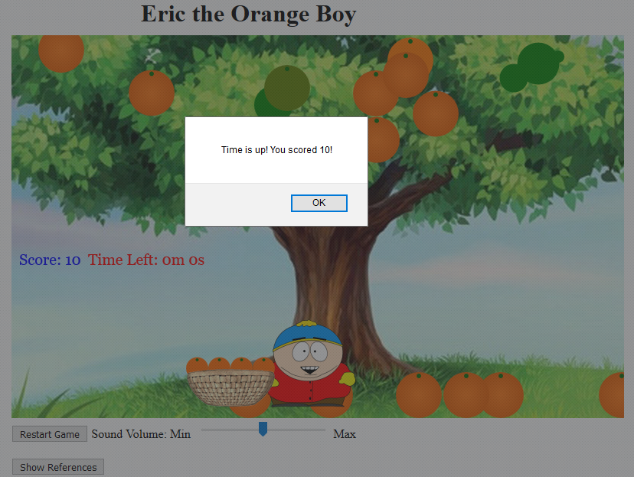

Description | Game Outro | Elements | - Info Window  - The outro music
Duration | Until user clicks ok | Elements animation | - The info window pops up.  - The outro music is played

